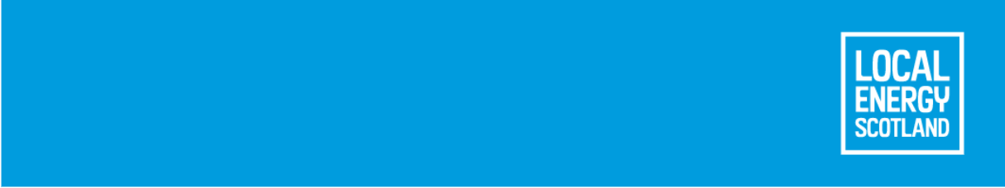
What the Onshore Wind Sector Deal means for Scottish communities

What is the Onshore Wind Sector Deal?
The Onshore Wind Sector Deal for Scotland (the Sector Deal) is a deal, signed in September 2023, between the Scottish Government and the Onshore Wind sector that will help to facilitate the Scottish Government’s ambition of reaching 20 gigawatts of onshore wind by 2030. The Sector Deal contains a series of commitments to be delivered by both the Scottish Government and the Onshore Wind sector to facilitate the delivery of this ambition in a way that is sustainable, inclusive, and economically prosperous. These include nine community commitments that ensure that impactful community benefits from and the option of shared ownership of renewable wind developments are offered to local communities. More information and updates on the commitments can be found on the Scottish Renewables website.

Good Practice Principles
The community commitments within the Sector Deal support the Scottish Government’s Good Practice Principles for community benefits and shared ownership from onshore renewable energy developments. The Good Practice Principles provide guidance on the voluntary agreements that onshore wind developers have agreed to meet or exceed. The Scottish Government is currently reviewing its Good Practice Principes for community benefits from onshore and offshore net zero energy developments. For more information about the Good Practice Principles, please see the following web pages:
- Community Benefits
- Shared Ownership

What does the Onshore Wind Sector Deal mean for communities?
In the Sector Deal developers have committed to engage with local communities about onshore wind projects at the earliest opportunity possible. This may be through letters/emails, or through reaching out to local community groups (such as community councils, village halls, sports clubs, faith groups, etc).
Developers who have signed up to the Onshore Wind Sector Deal have made the following commitments:
- To meet or exceed the Scottish Government’s Good Practice Principles for Community Benefits from Onshore Renewable Energy Developments and the Good Practice Principles for Shared Ownership from Onshore Renewable Energy Developments. These principles promote a package of community benefits of the value equivalent to £5,000 per installed megawatt per year, index linked for the operational lifetime of the project, whilst also recognising the need for flexibility in the packages offered to communities. For example, if the installed capacity of wind farm was 75 MWs (15 – 25 modern turbines) and the project developer offers the community a community benefit package of £5,000 per megawatt per year, this would provide a community benefits package equivalent to £375,000 per year. This amount will increase with the inflation measure cited within the community benefit agreement.
- Greater transparency in how the funds are spent, with community benefit package and shared ownership details updated annually on the Scottish Government’s register of community benefits and shared ownership.
- Offering a shared ownership opportunity, where a community organisation can invest in the projects to own part of the project, or a share in the revenue.
- Engaging with communities at the earliest possible opportunity to agree a community package (which could include community benefits and a shared ownership offer) that meets or exceeds the Scottish Government’s Good Practice Principles (see above).
- Providing an in-principle community benefit agreement prior to the developer’s decision to progress the project, described as the Financial Investment Decision (FID).
- Maintaining any community benefit agreement or shared ownership agreements or offer as a condition of sale, if the developer sells or transfers the project to another company. In the case of a project sale, it’s important for community benefit recipients and developers to understand the agreements between them so it can be transferred to the new owner.
- Working with communities to support more ambitious and strategic projects. Projects that contribute to a just transition to net zero are likely to be priorities where they match the needs of communities.
- Look for opportunities to take a co-ordinated approach to community benefit funds, for example where there are overlaps in the area of benefit from multiple projects in one area, as this can increase impact and reduce the administrative burden on local people.
- Working with key stakeholder organisations during pre-planning application to highlight community shared ownership opportunities. Ensuring that community organisations have sufficient time to explore these opportunities, which are more complex and are additional to any local community benefits.
Local Energy Scotland will maintain the register of community benefits and shared ownership, along with a community benefit toolkit. Advice and funding is available to help explore shared ownership opportunities.

Understanding shared ownership, community benefits and net zero support
What are Community Benefits?
Community benefits are voluntary packages of benefits (often in the form of funds but may also include other benefits) that renewable energy businesses provide to support communities. These offer an opportunity for communities to work with renewable energy businesses for the long-term benefit of the community. As of February 2025, community benefits of around £30 million per year are estimated across all renewable energy projects in Scotland. These are used to support a diverse range of activities and deliver tangible benefits to the lives of people across Scotland. Case studies are available on our website.
Local Energy Scotland have a register of community benefits, which is an online map and list showing the community benefits committed across Scotland. This covers different types of onshore and offshore renewable generation. The register demonstrates greater transparency in how funds are managed and spent, as the information on there is freely available and can be downloaded, filtered and searched in meaningful ways that will allow you as a member of the public to examine the impacts of community benefits in Scotland’s communities. The register is updated by renewable energy developers, project owners and fund administrators on a voluntary basis and is therefore not available for all projects. The accuracy of the register relies on information being uploaded regularly and accurately from these sources. More information about the register is available on our website.

What is Shared Ownership?
Shared Ownership is distinct, separate and is encouraged in addition to community benefits packages and is defined in the Scottish Government’s Good Practice Principles as “any structure which involves a community group as a financial partner over the lifetime of a renewable energy project”. Shared Ownership projects can take many forms, but the three most common are: joint ventures, shared revenue, and split ownership. More information on these can be found in our shared ownership resource.
Local Energy Scotland also maintain a register of shared ownership, showing where shared ownership has been offered on projects across Scotland.

Agreements include legal agreements like memorandum of understandings, heads of terms, community benefit agreements, shared ownership offer and also agreements of intent, for example commitments made in planning submissions or offered and minuted at community meetings.

