JOIN US!
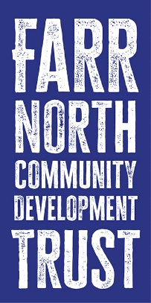
BECOME A MEMBER AND SHOW YOUR SUPPORT
Farr North Community Development Trust is working to breathe life and vitality into our communities. Formed in 2020, Farr North is a charity owned and run by its members. Membership is open to anyone aged over 16yrs who lives in the Parish of Farr (including, Bettyhill, Strathnaver, Altnaharra, Armadale, Strathy, Portskerra, Melvich, Strath Halladale.

Community Priorities | Some of the things we’ve done
Improve Community Meetings spaces | - We have helped £60,000 to help 5 local halls with general running costs
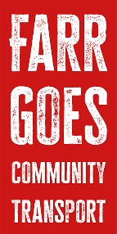  Transport : Helping people get to the places they need to for medical appointments, messages and social gatherings | - We manage two electric cars to take people where they need to be with our Farr Goes Project.  - We have a fund available to help people get driving qualifications
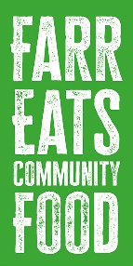  Caring for our vulnerable and our older people | - We have run hot meals delivery projects (Farr Eats) and distributed over 2000 meals.  - We have run a series of classes – art, flower arranging and photography, yoga, highland dancing and others.
Making the most of renewable energy. We want to maximise the community benefits from wind farms | - We are discussing shared ownership with local wind farm developers in our area.
Other things
- We have an apprenticeship programme to help our younger people gain the skills they need and equip them to stay and live in the area.
- We’ve run a pilot Women’s Health and Wellbeing group and are seeking funds to continue it.

Farr North Community Development Trust Office Holders (July 2025)
Abby Hardwick (Director) | Catherine Simpson (Director) | Caroline Easthope (Director)
Hugh Black (Director) | Khushla Celli (Director) | Susan Matthews (Director)
Kolin King (Bettyhill Strathnaver and Altnaharra Community Council Appointed Director) | Vacancy (Melvich Community Council Appointed Director) | Vacancy (Strath and Armadale Council Appointed Director)
Simon Lee Trust Manager and Company Secretary Manager@farrnorth.org.uk

Farr North Community Development Trust
Membership Form
It only costs £1 for life!
Full Name
Address
Postcode
Email Address
Date of Birth

I, the undersigned of the above address wish to apply to become a member of the above company.

Tick One Box
I live in the area of benefit, defined by the community council areas of Bettyhill, Strathnaver and Altnaharra, and Strathy and Armadale, and Melvich Voting Member
I live in the area of benefit, defined by the community council areas of Bettyhill, Strathnaver and Altnaharra, and Strathy and Armadale, and Melvich and am aged under 16 years old. Youth Member (non-voting)
I do not live in the area of benefit Associate Member (non-voting)

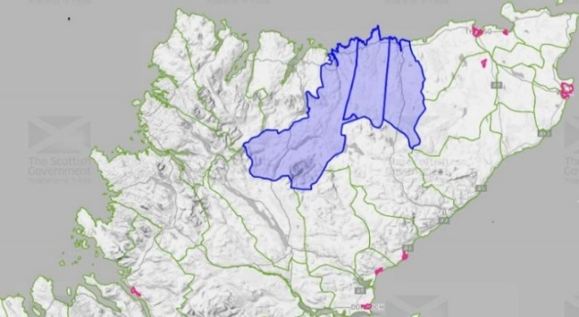
- I support the purposes of Farr North Community Development Trust and agree to be bound by the articles of the company’s articles of association.
- I authorise you to enter my name in the company’s register of members and to contact me from time to time in relation to the business of the company. Farr North Community Development Trust will never divulge your details to any third parties.
Signed | Print Name | Date

I enclose my membership subscription of £1 | And an additional donation of (optional!) | OR  I have paid by direct banking
Or pay by Direct Banking
Triodos Bank | Sort Code: 16-58-10 | Account Number:21481873
Account Name: Farr North Community Development Trust
Please return this form to
Farr North Community Development Trust, Naver Telecentre, Bettyhill KW14 7SS
manager@farrnorth.org.uk
Thank you!

