

HOUSING NEEDS SURVEY REPORT
For
FARR NORTH COMMUNITY DEVELOPMENT TRUST
December 2025




Contents
1. Executive Summary 4
1.2 Overall Executive Summary Conclusions 4
1.3 Key Themes Across All Areas 5
1.4 Community Council Summaries 5
Area A – Bettyhill, Strathnaver and Altnaharra 5
Area B – Strathy and Armadale 6
Area C – Melvich 6
1.5 Non-Resident summary 6
1.6 Business Findings 7
2 Methodology Overview 7
2.1 Map of the survey area 8
3 Permanent Resident’s Survey 9
3.1 Respondent Age Profile 15
3.2 Suitability of Current Households 17
3.3 Existing Residents wishing to move and stay in the Survey Area 18
3.4 Tenure Choices for those wishing to move house 20
3.5 Low-Cost Home Ownership Overview (LCHO) 22
3.6 Low-Cost Rent Overview 23
Housing availability (prospects) | Highland Housing Register Prospects 25
3.7 Self-Build Overview 25
3.8 Open Market Purchase Overview 27
3.9 Private Rent Overview 28
3.10 Accessible homes for Rent Overview 29
3.11 Renovation Overview 30
3.12 Respondents who have already tried to find alternative housing 30
3.13 Future Potential Independent Households in the Survey Area 31
3.14 Combined Housing Need for Current Residents & Future Households 32
4 General Community Views & Comments from the Community: 33
5 Non-Residents Survey 43
5.1 Respondent Profile 43
5.2 Housing Preferences for those wishing to relocate 45
5.3 Business Opportunities and Services 47
6 Business Needs Survey 48
6.1 Profile of Respondent looking to set up a new business 48
6.2 Profile of Respondents with an established business in the survey area 48
6.3 Businesses that have experienced staffing and recruitment problems 50
6.4 Businesses with employees who have a current housing need 51
6.5 Views on Housing Provision and Workspace Requirements 51
6.6 Business Growth and the Future 52
7 Final Conclusions 54
7.1 By Community Council Area 54
Area A – Bettyhill, Strathnaver and Altnaharra 54
Area B – Strathy and Armadale 54
Area C – Melvich 54
7.2 General Priorities 54
8 Next Steps 55
9 Appendix 1 - Tenure options summary 57

Executive Summary

The Communities Housing Trust (CHT) was commissioned by the Farr North Community Development Trust (FNCDT) to assess housing needs across three Community Council areas in North Sutherland:
- Area A – Bettyhill, Strathnaver and Altnaharra
- Area B – Strathy and Armadale
- Area C – Melvich

Overall Executive Summary Conclusions
There is a clear and evidenced demand for low cost, energy-efficient, and family-sized homes across all three community areas, with Area A – Bettyhill, Strathnaver and Altnaharra showing the most immediate need. Delivering new housing through a community-led, mixed-tenure approach will help retain and attract residents, support local businesses, and sustain essential services.
The Scottish Government defines affordable housing as “Housing of a reasonable quality that is affordable to people on modest incomes and that meets their needs.” And advises that housing costs should not exceed 25–30% of a household’s net income, and affordable housing products must be targeted at households who cannot meet their needs through the open market.
The report clearly indicates a need for Low Cost accommodation options, specifically
Low cost/Affordable rent
- Social Rent
- Provided by local authorities or housing associations at the lowest rent levels.
- Offers secure, long-term tenancies.
- Allocations are managed through the Highland Housing Register.
- Community-Owned Rent
- Homes owned and managed by a community organisation, typically let at social rent or below-market levels.
- Helps ensure the homes remain available to local people in perpetuity.

Low-Cost Home Ownership (LCHO)
Includes several models that support people who cannot afford open market prices:
- Discounted Sale / Rural Housing Burden
Homes sold at a permanent discount with resale restrictions to maintain affordability.
- Shared Equity (New Supply or Open Market)
Buyers purchase a share (usually 60–80%) with the remainder held by the Scottish Government or an RSL.
- Rent to Buy
Residents rent for several years at a reduced rate, with an option to purchase later at a discounted price.

Key Themes Across All Areas
  - Strong demand for low cost homes to rent or buy.
There is clear, consistent pressure for low-cost homes to rent or buy, particularly 2- and 3-bed family-sized properties. These options are essential for retaining young families and supporting older residents to downsize into suitable accommodation.
  - Demographic imbalance.
An ageing population, combined with limited housing opportunities for younger adults and families, is contributing to declining school rolls and shrinking local workforces. Without intervention, this imbalance threatens the long-term viability of community services.
  - High prevalence of second homes and short-term lets.
High levels of non-permanent occupancy are restricting housing supply for local people, inflating prices, and limiting options for those wishing to remain in or relocate to the area.
  - Impact on businesses.
Employers report recruitment and retention challenges closely tied to the lack of affordable, secure housing for staff. This is restricting business growth and service provision, including in education and health.
  - Strong community attachment and desire to stay
Despite constraints, residents, especially younger adults and potential new households, express a strong desire to remain in or relocate to the area if suitable housing becomes available. This reinforces the need for a community-led approach to sustainable, long-term housing solutions.

Community Council Summaries

Area A – Bettyhill, Strathnaver and Altnaharra
Area A accounts for the majority of survey responses (75%) and shows the most significant and immediate housing pressures.
Key findings include:
- Highest level of expressed housing need, with 19 of the 33 households seeking housing within five years located here.
- Strong presence of families with children and future household formation, making it the priority area for stabilising school rolls.
- Clear preference for Low-Cost Home Ownership and Low-Cost Rent, reflecting both affordability constraints and a desire for secure, long-term options.
- Evidence of downsizing needs among older residents seeking accessible or appropriately sized homes.
- Local businesses are facing recruitment challenges due to housing shortages, affecting essential local services.
Recommended approach:
A first-phase development of up to 20 mixed-tenure homes, delivered through community-led housing with partners including Highland Council, RSLs, CHT, and the NHS. This scale of development would make a meaningful impact on schools, services, and local employment stability.

Area B – Strathy and Armadale
While survey numbers are smaller, the responses reveal important community needs:
- Proportionally notable housing pressure, despite the modest number of survey returns.
- Limited local supply and low awareness of affordable rental or ownership options.
- Identified need for smaller, adaptable homes, especially for older residents wishing to remain in the community.
- Demand for affordable rental and entry-level ownership options for those unable to secure housing on the open market.
Recommended approach:
A targeted small-scale development of 4–6 homes, focused on low-cost rent and low-cost ownership. Community-led delivery aligned with Highland Council and RSL partners would ensure long-term affordability and suitability for older households and smaller families.

Area C – Melvich
Although the fewest resident responses were received, the area exhibits clear and growing housing-related pressures:
- Strong non-resident interest, particularly from working-age adults and families wishing to relocate for employment or family support.
- Businesses report recruitment difficulties due to a lack of available, affordable homes.
- Demand centred on 2–3 bedroom family homes, primarily for low-cost rent.
Recommended approach:
Delivery of 4–6 affordable homes, strategically aligned with local employer needs. A community-led partnership model involving RSLs, Highland Council, CHT, local businesses and institutions such as the NHS would maximise economic impact and ensure housing meets workforce requirements.

Non-Resident summary
The survey shows significant external interest in relocating to the Farr North area, particularly from working-age adults and families seeking long-term housing. This demand represents an important opportunity to reverse population decline, but only if suitable and affordable homes are available.
Key insights include:
- 15 households wish to relocate, the majority being families with children or adults of working age, groups vital to sustaining local schools, services, and the labour market.
- Affordability and availability are the main barriers. Most prospective residents were unable to secure a suitable home despite actively searching across the area.
- Interest spans multiple tenures, with strong demand for low-cost rent, open-market purchase, and low-cost ownership options.
- Rental budgets of £400–£600 per month and modest purchasing budgets indicate that market prices and rising private rents place many properties out of reach.
- Many non-residents cited local employment opportunities, family ties, and lifestyle reasons as key drivers for moving, suggesting relocation would be permanent rather than seasonal.
- A high number of prospective movers have already attempted to secure housing, indicating strong intent rather than speculative interest.

Overall, the non-resident survey responses highlight a ready and motivated group that could strengthen local services and community vitality, if new affordable homes are delivered across all three Community Council areas.

Business Findings
The business survey clearly demonstrates that housing shortages are already constraining the local economy, limiting recruitment, retention, and future growth across multiple sectors.
Key findings include:
- Several businesses, spanning education, tourism and other sectors, report losing staff or being unable to recruit because potential employees cannot find secure housing locally.
- Employers describe having to reduce services, delay projects, or operate below capacity due to labour shortages linked directly to housing availability.
- No businesses currently provide staff housing, but some express strong interest in doing so if suitable models can be developed.
- Businesses highlighted a lack of temporary or seasonal accommodation, limiting their ability to bring in short-term or specialist workers.
- Where businesses anticipate growth, they also anticipate a clear need for 1–2 additional affordable homes for new employees, confirming housing is a critical enabling factor for expansion.
- Employers identify low cost rent as the most urgently needed tenure for staff, followed by shared equity or low-cost ownership options.
In summary, employers view housing shortages as a major operational risk. Without new affordable, long-term housing, particularly in Area A – Bettyhill, Strathnaver and Altnaharra, as well as Area C - Melvich, local businesses face continued recruitment barriers, higher costs, and limited growth potential. Addressing this need is essential to securing a stable workforce, safeguarding local services, and supporting economic resilience.

Methodology Overview
Surveys were distributed online and promoted locally through social media, posters with QR codes, and six in-person engagement events (two in each area community council area). Supplementary data was drawn from Highland Council, Scottish Census 2022, and other public datasets.
A total of 52 resident responses were received (approximately 9% of households in the survey area), in addition to responses from prospective residents and local businesses.
In common with most surveys, this report provides a snapshot of the potential housing need at the time of writing. The data represents only the proportion of those who took part in the survey, and whilst some questions in the surveys were mandatory, it is important to note that most were not, and respondents therefore only answered questions they wished to answer. Consequently, response rates for questions vary.

Map of the survey area
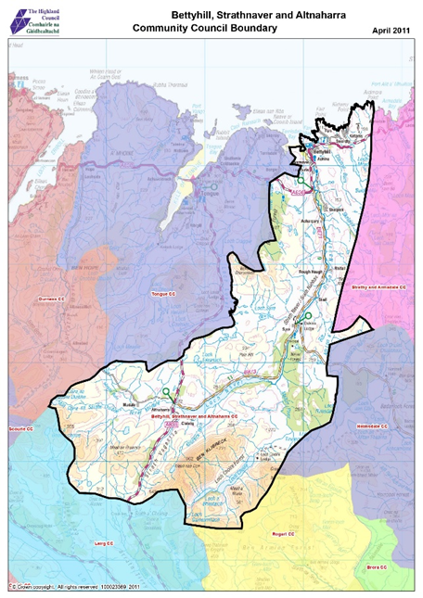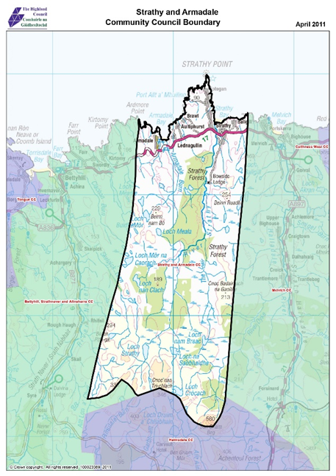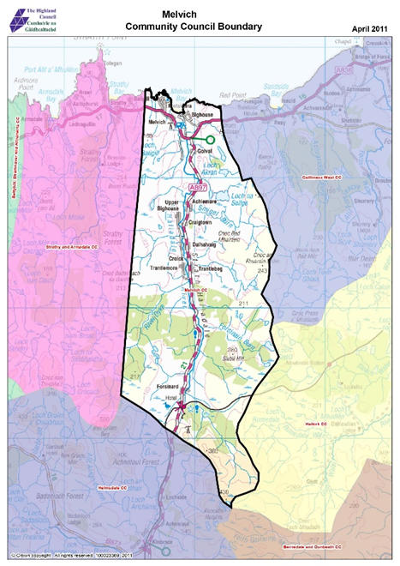
https://www.highland.gov.uk/downloads/download/472/community_councils_-_boundary_maps

Permanent Resident’s Survey

- The survey received 52 responses from householders who permanently live in the survey area. The breakdown of households by Community Council area is as follows:
  - Area A - Bettyhill Strathnaver and Altnaharra - 39
  - Area B - Strathy and Armadale - 6
  - Area C – Melvich - 5
  - Not provided - 2
- There are approximately 590 households in the survey area (data from Highland Council)
  - Area A - Bettyhill Strathnaver and Altnaharra - 259
  - Area B - Strathy and Armadale - 126
  - Area C – Melvich – 205
- Based on the response to this survey of 52, only 9% of households within the survey area have engaged with this survey. The percentage of households responding in each community council area is
  - Area A - Bettyhill Strathnaver and Altnaharra – 15%
  - Area B - Strathy and Armadale – 5%
  - Area C – Melvich – 2%

- Similar to these survey results, Census 2022 results for North, West and Central Sutherland show that most occupied households are owner occupiers https://www.scotlandscensus.gov.uk/ However, when looking at the provision of social housing, Highland-wide average results show 20% average for social housing compared to only 13% in North, West and Central Sutherland:

Tenure | Highland wide census 2022 % | North, West and Central Sutherland % | CHT Survey %
Owner Occupied | 67 | 71 | 63
Social Rent | 20 | 16 | 13
Private Rent | 11 | 8 | 6
Lives Rent Free | 2 | 5 | 10
Tied | 0 | 0 | 2
Lives with Parents | 0 | 0 | 4
Other | 0 | 0 | 2
Table: Tenure Results for Survey in Comparison to 2022 Census

- The Short Term Let Public Register shows a list of short-term licence applications for the Highland Council. A search for Highland Council Ward 1 – Northwest and Central Sutherland showed that at the time of writing this report, there were 488 registered properties. Information for the public register | Short term lets public register | The Highland Council.

- Short-term lets alone account for a significant number of properties. The figures above do not include second homes. There are concerns that a high concentration of second homes can increase house prices, reducing the housing supply for local people. Second homes in Scotland – facts, figures and policy – SPICe Spotlight | Solas air SPICe

Respondent Age Profile

- Many rural areas are struggling to retain young people. This presents the challenge of providing low cost housing to retain and attract younger people whilst also providing accommodation for the ageing population.
- 33% of households have children aged 15 or under.
  - 76% of those live in Area A – Bettyhill, Strathnaver and Altnaharra
  - 6 % of those live in Area B - Strathy and Armadale
  - 18% of those live in Area C - Melvich
- Over a third of households include one resident aged over 65 or over (37%).
  - 74% of those live in Area A – Bettyhill, Strathnaver and Altnaharra
  - 16% of those live in Area B - Strathy and Armadale
  - 11% of those live in Area C – Melvich
- The 2022 data showed that 23.7% of residents within the Highlands were 65 and over, compared to 30.1% in Sutherland. The age profile of the Sutherland population is older than Highland and has increased by 2% over the period from 2002 to 2021. Over the same period, there was a 38% increase in the 65+ age group and a decrease of 3% in the population aged 16-64, and the population under 16 decreased by 27%. The ratio of 1.9 people of working age (16-64 years) to older people (age 65 years and over) is lower than in Highland and Scotland.
https://www.nhshighland.scot.nhs.uk/media/5rfpcwpc/demography-sutherland-2022.pdf

The Sutherland Area Place Plan comparison of census data from 2011 and 2022 shows a decrease of 20.9% in the under-15 age group and an increase of 22.9% in the over-65 age group.
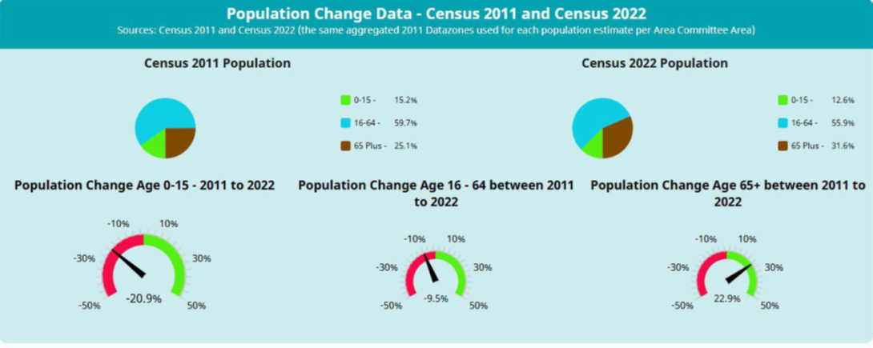
https://www.highland.gov.uk/download/meetings/id/85050/6_sutherland_area_place_plan_report
- The school roll for Farr Primary in Bettyhill for 2025 is currently 31 (62% roll/total capacity), and it is forecast to decline to 52% by 2035.
- The school roll for Melvich Primary for 2025 is 34 (68% roll/total capacity), and it is forecast to decrease to 54% by 2035.
- The school roll for Farr High School for 2025 is 72 (31% roll/total capacity) and is forecast to fluctuate over the next decade, reducing to 28% capacity by 2035.

https://www.highland.gov.uk/downloads/file/29505/school_rolls_2024-2025 https://www.highland.gov.uk/download/downloads/id/30024/school_core_facts_summary.pdf
https://www.highland.gov.uk/downloads/download/2490/school_roll_forecasts_march_2025

- Given that the primary schools are operating at less than 70% capacity, and the High School is operating at less than a third of its capacity, any future housing projects should be mindful of this. There is a need to attract and retain economically active people, and those with school children, to sustain the local economy, services, and local school roll.

Suitability of Current Households

- No survey respondents class themselves as homeless or at risk of becoming homeless.

- A minority of survey respondents (10%) said “yes” to their current home being too large and that they would benefit from moving to a smaller home (5) either now or in the future:

- Age Scotland’s Chief Executive, Brian Sloan, recognises the widespread issue of people wishing to downsize but not being able to: "Too many older people are already stuck living in unsuitable accommodation and unable to move or downsize if they wish. Scotland must future-proof its housing stock by building more affordable, adaptable homes to allow people to continue living independently in their communities. Ensuring older people are able to stay connected to communities, services, and people is also vital in tackling the acute issues of loneliness and social isolation.” Scotland must rise to meet the needs of an ageing population (ageuk.org.uk)

- 17% said that their current home does not meet the needs of all householders (9).
  - 56% (5) of those live in Area A – Bettyhill, Strathnaver and Altnaharra
  - 33% (3) of those live in Area B - Strathy and Armadale
  - 11% (1) of those live in Area C – Melvich

- The majority are owner occupiers, 56% (5), and two respondents live in Area A – Bettyhill, Strathnaver and Altnaharra and the other three live in Area B - Strathy and Armadale.

- 2 out of the 9 (22%) who said that their homes do not currently meet the needs of all householders are considering moving home. One respondent live in Area A – Bettyhill, Strathnaver and Altnaharra and the other lives in Area B - Strathy and Armadale.

- The size and condition of properties were the reason for housing not meeting current needs.

Existing Residents wishing to move and stay in the Survey Area

- Overall, 29% (15) of survey respondents said “yes” to considering moving home and staying in the survey area.
- The majority looking to move currently reside in Area A – Bettyhill, Strathnaver and Altnaharra (73%), and current tenures vary:

 | Area A – Bettyhill, Strathnaver and Altnaharra | Area B - Strathy and Armadale | Not provided | Total
Living rent free | 2 | 1 |  | 3
Living with my parents |  | 1 |  | 1
Living with parents | 1 |  |  | 1
Other | 1 |  |  | 1
Owns outright or with a mortgage or loan | 3 |  |  | 3
Owns with shared equity |  |  | 1 | 1
Private rent | 2 |  |  | 2
Rents from the council or housing association | 2 | 1 |  | 3
Total | 11 | 3 | 1 | 15
- No respondents looking to move lived in Area C – Melvich.
- Out of the 15 households looking to move, 6 (40%) have at least one dependent child.
  - 83% (5) of those live in Area A – Bettyhill, Strathnaver and Altnaharra
  - 17% (1) of those live in Area B - Strathy and Armadale
  - 0% (0) of those live in Area C – Melvich

- Most (8) would be looking to move home in the short-term, within the next 1 to 3 years:
  - 75% (6) of those live in Area A – Bettyhill, Strathnaver and Altnaharra
  - 13% (1) of those live in Area B - Strathy and Armadale
  - 0% (0) of those live in Area C – Melvich

- Respondents were asked to select the main reason(s) for wishing to move home, and most selected multiple reasons, with the top two reasons being: overcrowding, to set up as an independent household and that there were not enough suitable houses in the area.

- 2 out of the 4, which selected overcrowding, are households with one or more children aged 16 or under.

Tenure Choices for those wishing to move house
- All respondents who wished to move house (17) were presented with seven tenure choices and asked to select their first-choice tenure option for their new home, along with their preferred location.
- Respondents showed interest in 4 out of the 7 tenures, with the low-cost options of low-cost home ownership (6) and low-cost rent (5) being the two most popular options.
- As well as selecting tenure choice, respondents were also asked to indicate where in the area they would like their new home to be; the majority of respondents chose Area A – Bettyhill, Strathnaver and Altnaharra.
- The survey indicates a higher demand for two-bedroom homes. A breakdown of all preferred tenures, bed choices and locations is as follows:

Preferred Tenure Summary

How many bedrooms respondents need Where respondents want to live

 | Area A - Bettyhill Strathnaver and Altnaharra | Area B - Strathy and Armadale | Area C - Melvich | All of the above | Not stated | Total
Low-cost home ownership | 2 | 2 | 1 | 1 |  | 6
Low-cost rent | 5 |  |  |  |  | 5
Self-Build | 1 | 1 |  |  |  | 2
Buy on the open market | 2 |  |  |  |  | 2
Private rent
Accessible housing
Not stated |  |  |  |  | 2 | 2
Total | 10 | 3 | 1 | 1 | 2 | 17

Low-Cost Home Ownership Overview (LCHO)
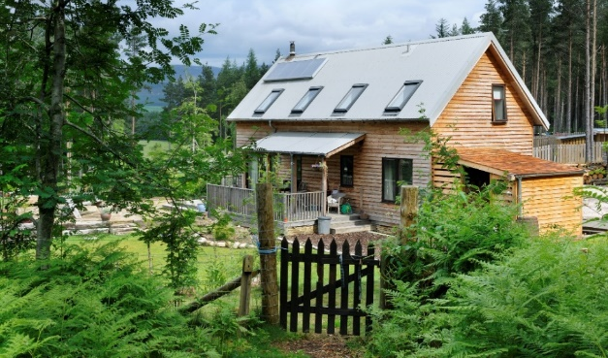
Low-cost home ownership units are properties sold at a reduced cost to people who wish to purchase a property but cannot afford to buy on the open market.
There are various options on how low-cost homeownership can be delivered and these are outlined fully in Appendix 1. One option for delivering LCHO homes is through community-led housing with CHT, and other rural housing bodies, securing a discount on the sale prices of homes, through the Rural Housing Burden.
Ardgeal, Kincraig

- A breakdown of bedroom requirements for those interested in LCHO indicate that 2-bedroom properties are the preference in all areas served.

 | 1 bedroom | 2 bedrooms | 3 bedrooms | 4 bedrooms or more | Total
Area A – Bettyhill, Strathnaver and Altnaharra |  | 1 | 1 |  | 2
Area B - Strathy and Armadale |  | 1 | 1 |  | 2
Area C - Melvich |  | 1 |  |  | 1
All of the above |  | 1
Total |  | 4 | 2 |  | 6

- Combined household incomes vary for those interested in LCHO. Based on household income alone, those with under £30,000 may not be able to finance the purchase of a LCHO home, and low-cost rent may be a more realistic tenure option.

- The Rural Housing Burden can be applied to this type of tenure and will ensure that homes are kept affordable in perpetuity and not lost to the open market.

- Other shared equity options for FNCDT or other community body to consider are New Supply Shared Equity and Open Market Shared Equity (this scheme has stopped accepting applications for 2024 to 2025).

Low-Cost Rent Overview
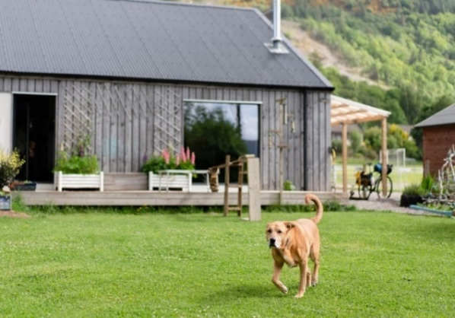
Low-cost rent levels are significantly lower than a tenant would pay in the normal market, with social rented housing, being provided by the local authority or by housing associations, being the most affordable rented housing option, along with offering secure tenancies.
Community-owned rented housing is another method of providing low-cost rented homes in a community, where the community owns the home and it is rented out, usually at social rented housing levels.

CHT home in Balmacara, rented under RTB scheme.

- 5 respondents selected the first-choice tenure of low-cost rent, with most demand for 3-bed homes.
- All respondents selected Area A – Bettyhill, Strathnaver and Altnaharra as the preferred location for their new house:

 | 1 bedroom | 2 bedrooms | 3 bedrooms | Total
Area A - Bettyhill Strathnaver and Altnaharra | 1 | 1 | 3 | 5
Total | 1 | 1 | 3 | 5

- Most respondents selected a monthly rental budget of less than £600 per month. Based on the current local housing allowance rate, depending on the exact budgets and beds required by respondents, rents based on these rates may not be affordable:

Table: Local Housing Allowance Rates Local Housing Allowance Rates: 2024-2025 - gov.scot (www.gov.scot)
 | 1 Bed Shared | 1 Bed | 2 Bed | 3 Bed | 4 Bed
Weekly Rent | 87.45 | 109.32 | 136.93 | 159.95 | 195.62
Monthly rental equivalent | 378.95 | 473.72 | 593.36 | 693.12 | 847.69

- Community groups, that own community housing have flexibility and discretion around the rent levels set. These groups can devise their own allocation policies, and this is an option worth considering, as they are not bound by LHA rates.

- CHT’s RouteMap is a free guide for community organisations interested in undertaking their own housing or development.

- There is a common housing register in Highland called the Highland Housing Register, for those interested in social housing. The list on 1 April 2025 shows registered interest for housing in the survey area as:

Housing availability (prospects) | Highland Housing Register Prospects

- 2 out of the 4 that selected low-cost rent as their preferred tenure are currently registered on the HHR.
- No respondents said “yes” to considering shared accommodation in a house or flat.

- Anecdotal evidence from CHT’s work in other communities suggests that many people looking for housing do not register on Common Housing Registers as they do not think that they will be successful in finding a house through this route, and either find other temporary housing solutions, move somewhere else or rent privately instead.

Self-Build Overview
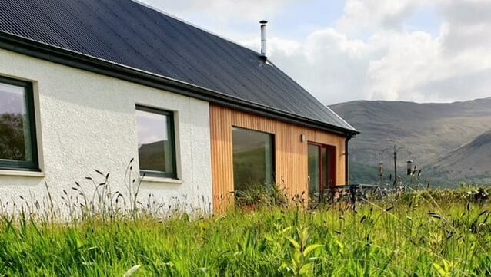
Plots for self-build are mostly available through open market sale through a range of sellers or discounted self-build plots, that are offered for sale at less than market prices.
Schemes such as the Self-Build Loan Fund (SBLF) and Croft House Grant Scheme are available to help those interested in a self-build project.
Scotland's Self-Build Loan Fund - Communities Housing Trust (chtrust.co.uk)
House in Mull constructed under SBLF.

 | 2 bedrooms | 3 bedrooms or more | Total
Area A - Bettyhill Strathnaver and Altnaharra | 1 |  | 1
Area B - Strathy and Armadale |  | 1 | 1
Total | 1 | 1 | 2

- Both respondents who selected the option of self-build already own a plot. One household has a combined household income of over £40,000 plus and the other has a combined income of under £20,000.
- Self-build mortgages are available in Scotland, whereby mortgage lenders loan the money in stages as the house is built. However, many mortgage lenders will not lend any loan payments until the build is at wind and watertight stage.
- The Self-Build Loan Fund is a Scottish Government initiative to assist self-builders, who have been unable to obtain mainstream mortgage finance. The fund is repaid upon obtaining a mainstream mortgage upon completion of the project or by using the equity following the sale of the existing home.
- Due to current construction costs, linked to recent increases in labour and material costs, anyone embarking on a self-build project should carefully work out project costs before commencing on a self-build.
- Given the small demand for self-build, along with current construction costs, the inclusion of discounted self-build plots should be very carefully considered as part of any future development, and only if there is sufficient demand and project costs and finance are viable.

Open Market Purchase Overview
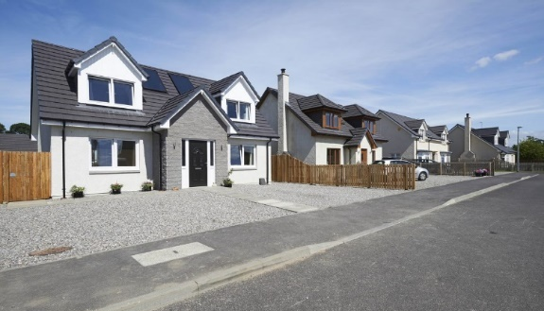
Information from Rightmove at the time of writing this report states that average house prices within the survey area are
Area A – Bettyhill, Strathnaver and Altnaharra - £215,000
Area B - Strathy and Armadale - £167,500
Area C – Melvich - £128,000
https://www.rightmove.co.uk/house-prices.html

Simpsons Park, Beauly
The average salary in Scotland in 2024 was £38,464.40 per year (£739.70/ week). However, the Highlands were one of the lowest paid regions, with a median weekly pay of £591.00.
https://www.gov.scot/publications/annual-survey-of-hours-and-earnings-2024/pages/employee-earnings/
https://www.ons.gov.uk/employmentandlabourmarket/peopleinwork/earningsandworkinghours/datasets/placeofresidencebylocalauthorityashetable8#:~:text=About%20this%20Dataset,zip%20(5.8%20MB)
 | 2 bedroom | 4 bedrooms | Total
Area A - Bettyhill Strathnaver and Altnaharra | 1 | 1 | 2
Total | 1 | 1 | 2

- Only two chose this option and they were based in Area A – Bettyhill, Strathnaver and Altnaharra.

- Mortgage Lenders typically lend 3 to 4.5 on salaries and based on a household income of £40,000, and with an average house price of £215,000 in Area A – Bettyhill, Strathnaver and Altnaharra, purchasing on the open market may not be affordable for those who selected this tenure, and LCHO may be a more realistic option.

- In general, housing for open market purchase, and housing developed as part of a mixed tenure development and sold on the open market, may provide cross-subsidy to help finance low-cost tenures and this is an option worth fully exploring for any future housing development.

Private Rent Overview
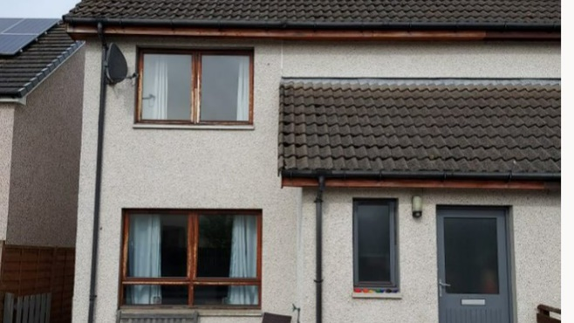
The basic Private Rented Sector definition of a private rent is a property owned by a landlord and leased to a tenant. The landlord could be an individual, a property company, or an institutional investor.

Since December 2017, almost all new private sector tenancies where someone moves into accommodation that is to be their main residence will be a private residential tenancy; normally abbreviated to “PRT”.

- 5 respondents chose this option and all chose Area A – Bettyhill, Strathnaver and Altnaharra.

 | 1 Bedroom | 2 bedrooms | 3 bedroom | Total
Area A - Bettyhill, Strathnaver and Altnaharra | 1 | 1 | 3 | 5
Total | 1 | 1 | 3 | 5

- At the time of writing this report, an initial search on rightmove.com, onthemarket.com and zoopla.com for rental properties within a 30-mile radius of Bettyhill was undertaken
  - There were no properties available on Rightmove.
  - On the Market had two residential properties for rent, a 4-bedroom property in Halkirk for £950 pcm and a 1-bedroom property in Forss for £600pcm
  - Zoopla had a 1-bedroom property in Thurso, for £410pcm – this was a social rental property offered by Cairn to those over 50.

- Given rising rent prices, it is worth noting that private rent is no longer an option for many: “2 bedroom properties are the most common privately rented property in Scotland. Average 2 bedroom properties rents in Scotland rose by 6.2% in the year to end September 2024 to reach £893 per month, up £52 per month compared with the previous year”. www.gov.scot/publications/private-sector-rent-statistics-scotland-2010-to-2024
- In general, over recent years the high number of short-term lets in the area has impacted the availability of privately rented accommodation
- Given the high rents charged by some landlords, along with limited availability in the private rented sector, community owned rented housing with more affordable rent levels may be a more appealing option for those interested in renting.

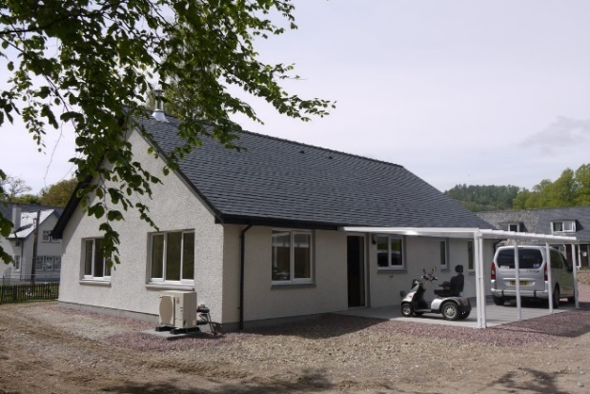
Accessible homes for Rent Overview
These are homes built to be flexible and adaptable, incorporating elements to support the changing needs of individuals and families at various stages of life. As part of the Scottish Government’s new Housing 2040 strategy, it has published a new accessibility standard as part of a new housing strategy that will mean, for the first time, homes in Scotland will have to meet a certain level of accessibility.
CHT Adapted Built home, Invergarry.

- No respondents were looking for an accessible home.
- Three respondents had members of the household who would be moving out within the next five years and would require an accessible home. All have selected Area A – Bettyhill, Strathnaver and Altnaharra as their preferred location.
- Following the results of the 2022 census, which showed that people aged 65 and over generally outnumber people aged under 15 throughout Scotland. Jon Wroth-Smith, Director of Census Statistics, National Records of Scotland, commented that “it is important that we understand how our population is ageing so we can prepare for it. These changes will put greater demand on health and social care services." Accessible, adaptable and flexible housing may be one such measure that could help with these demands.
- Further details on the accessible standard can be found in the guidance: Housing 2040: Scottish Government Accessible Housing standard - Disability Equality Scotland Access Panel Network

Renovation Overview
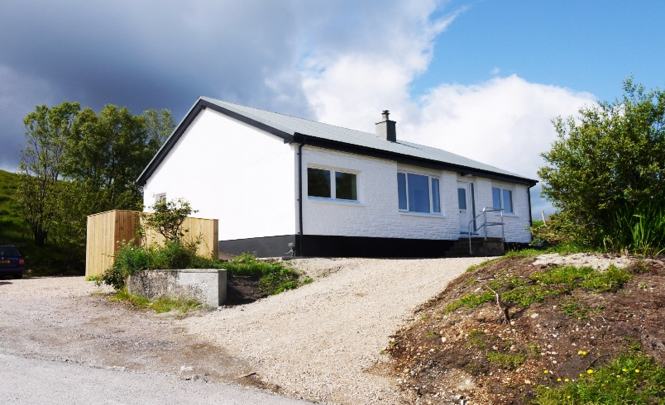
As a rough guide, Checkatrade estimates it will cost between £43,530 and £110,350 to fully renovate a three-bedroom house. They also recommend a contingency of 15%

With inflation still running high, builders in demand and materials sometimes in short supply, home renovators are finding themselves shelling out a lot more for projects now than they did pre-pandemic. How much do home renovations cost? - Zoopla

- Although not offered as a tenure choice, bringing empty homes back into use can increase housing supply, improve community safety and contribute to regeneration. Highland Council can provide advice and assistance on ways to bring empty properties back into use. Empty Homes | Empty Homes | The Highland Council

Respondents who have already tried to find alternative housing

- Most respondents wishing to move home have already tried to find alternative housing (8). 50% of whom (4) would consider looking for suitable housing out with the survey area if they cannot find a suitable home.
- It is therefore a concern that so many respondents would consider leaving the area if they cannot find suitable housing. Most of the households that would consider leaving the area are households with one or more dependent children (3), and the remaining households contain two or more adults under 65 (2).
- Keeping people in the area who are economically active is vital to the local economy.

Future Potential Independent Households in the Survey Area

- A major challenge for many rural communities in Scotland is depopulation, with many young people leaving the areas in which they were raised because of a lack of suitable housing or employment, or to access further education. The Scottish Government have recognised this in their plans to reinvigorate Scotland’s rural communities. The Scottish Government’s ‘Housing to 2040’ policy has made the engagement of young people an important part of shaping the 20-year housing strategy.
- In trying to assess potential future housing demand, respondents were asked if any current members of their household were planning to move out of their household and required independent accommodation in the survey area within the next 5 years. Overall, the survey identified 16 such potential new future households.
- Respondents were presented with tenure choices for these potential future households and asked to select a first-choice tenure preference, along with if preferred area and the results were as follows:

- The survey identified that there was mainly support for low cost tenures, both to rent and buy, for potential future households, with stronger interest in 2 or 3 bed homes:

- At present, only 4 potential future household leavers are known to be currently registered on the Highland Housing Register
- It is encouraging from the results of this survey that people wish to remain in the area, and providing a range of low cost housing options may be key to ensuring that younger people do not have to leave the survey area.

Combined Housing Need for Current Residents & Future Households

- When looking at the housing need for both current residents wishing to move home and stay in the area, along with future independent households, there are 33 potential households looking to move/set up a new home in the next 5-year period.
- Based on the results of this survey, a mixed tenure development, both with low-cost homes, to rent and to buy, would best meet demand, with any new homes being built in Area A – Bettyhill, Strathnaver and Altnaharra.

Table: Combined housing need for current residents and future potential households
 | Area – A Bettyhill, strathnaver and Altnaharra | Area B – Strathy and Armadale | Area C – Melvich | Would accept all areas | Not applicable | Not stated | Total
Accessible home | 1 |  |  |  | 2 |  | 3
Buy on the open market | 2 |  |  |  |  |  | 2
Low cost home ownership | 4 | 7 | 1 | 1 |  |  | 13
Low cost rent | 10 |  |  |  |  |  | 10
Private rent | 1 |  |  |  |  |  | 1
Self build | 1 | 1 |  |  |  |  | 2
Not stated |  |  |  |  |  | 2 | 2
Total | 19 | 8 | 1 | 1 | 2 | 2 | 33

General Community Views & Comments from the Community:
- All respondents were presented with 14 statements relating to housing provision in the area and community needs re future housing and were asked to what extent they agreed or disagreed with the statements.
- The majority of respondents strongly agreed that there is a need for more affordable housing (69%). The majority of respondents also agreed that local people (60%) with families (48%) or family connections (31%) or where housing will support employment (60%), should get priority for any new affordable homes in the area and that new housing should also be built to high energy efficiency standards (65%).
- There was also strong support for the statement that local people have had to leave the area because they cannot find suitable housing locally, with 46% agreeing with this statement.

- Following on from this, respondents were asked to rate the access to services in the area. Excluding where an answer wasn’t stated or if don’t know / not sure / not applicable was selected, residents generally agree with the statements except where access to transport was discussed.

- The table below gives a full breakdown of the communities views on the statements:

Overall Responses – housing provision
 | Strongly Agree | Generally  Agree | Don’t know / not sure | Generally Disagree | Strongly Disagree | Not stated
Our community needs more affordable housing | 36 | 7 | 3 |  | 1 | 5
Local people have had to leave the area because they could not find suitable housing | 24 | 9 | 12 | 2 |  | 5
Most people who live in our area want to stay permanently | 22 | 18 | 7 |  |  | 5
Applicants who live and work in the immediate surrounding area should get priority for new affordable homes | 31 | 12 | 4 |  |  | 5
Applicants who have a family connection should get priority for new affordable homes | 16 | 17 | 8 | 6 |  | 5
Applicants from outside our community area should get priority for any new affordable housing | 1 | 2 | 14 | 23 | 7 | 5
The people of our community welcome newcomers from other communities to live here | 8 | 28 | 10 | 1 |  | 5
Our community needs more smaller, accessible homes | 17 | 14 | 12 | 1 | 1 | 7
It is important that new housing is built with high energy efficiency standards | 34 | 12 | 1 |  | 1 | 4
There are too many second homes in our community | 23 | 7 | 12 | 4 | 2 | 4
Local people will have to leave the area because they cannot find suitable housing | 21 | 14 | 9 | 2 | 1 | 5
Our community needs more housing for families | 25 | 14 | 7 |  | 1 | 5
It is important that any new housing built has a provision for working from home | 15 | 10 | 17 | 4 | 1 | 5
Employers, including schools and health services, struggle to recruit staff because potential employees can't find suitable housing | 31 | 12 | 4 |  | 1 | 4

Housing provision responses from Area A - Bettyhill Strathnaver and Altnaharra
 | Strongly Agree | Generally  Agree | Don’t know / not sure | Generally Disagree | Strongly Disagree | Not stated
Our community needs more affordable housing | 30 | 3 | 2 | 0 | 0 | 1
Local people have had to leave the area because they could not find suitable housing | 18 | 7 | 9 | 1 | 0 | 1
Most people who live in our area want to stay permanently | 18 | 12 | 5 | 0 | 0 | 1
Applicants who live and work in the immediate surrounding area should get priority for new affordable homes | 23 | 10 | 2 | 0 | 0 | 1
Applicants who have a family connection should get priority for new affordable homes | 12 | 14 | 7 | 2 | 0 | 1
Applicants from outside our community area should get priority for any new affordable housing | 0 | 2 | 9 | 18 | 6 | 1
The people of our community welcome newcomers from other communities to live here | 7 | 21 | 6 | 1 | 0 | 1
Our community needs more smaller, accessible homes | 14 | 7 | 11 | 1 | 0 | 3
It is important that new housing is built with high energy efficiency standards | 27 | 8 | 1 | 0 | 0 | 0
There are too many second homes in our community | 18 | 6 | 9 | 3 | 0 | 0
Local people will have to leave the area because they cannot find suitable housing | 15 | 12 | 7 | 1 | 0 | 1
Our community needs more housing for families | 20 | 11 | 4 | 0 | 0 | 1
It is important that any new housing built has a provision for working from home | 11 | 7 | 14 | 3 | 0 | 1
Employers, including schools and health services, struggle to recruit staff because potential employees can't find suitable housing | 26 | 8 | 2 | 0 | 0 | 0

Housing provision responses from Area B - Strathy and Armadale
 | Strongly Agree | Generally  Agree | Don’t know / not sure | Generally Disagree | Strongly Disagree | Not stated
Our community needs more affordable housing | 2 | 3 | 1 | 0 | 0 | 0
Local people have had to leave the area because they could not find suitable housing | 2 | 2 | 2 | 0 | 0 | 0
Most people who live in our area want to stay permanently | 2 | 3 | 1 | 0 | 0 | 0
Applicants who live and work in the immediate surrounding area should get priority for new affordable homes | 3 | 2 | 1 | 0 | 0 | 0
Applicants who have a family connection should get priority for new affordable homes | 1 | 3 | 1 | 1 | 0 | 0
Applicants from outside our community area should get priority for any new affordable housing | 0 | 0 | 3 | 3 | 0 | 0
The people of our community welcome newcomers from other communities to live here | 0 | 3 | 3 | 0 | 0 | 0
Our community needs more smaller, accessible homes | 2 | 3 | 1 | 0 | 0 | 0
It is important that new housing is built with high energy efficiency standards | 3 | 3 | 0 | 0 | 0 | 0
There are too many second homes in our community | 2 | 1 | 2 | 1 | 0 | 0
Local people will have to leave the area because they cannot find suitable housing | 2 | 2 | 2 | 0 | 0 | 0
Our community needs more housing for families | 1 | 3 | 2 | 0 | 0 | 0
It is important that any new housing built has a provision for working from home | 3 | 0 | 3 | 0 | 0 | 0
Employers, including schools and health services, struggle to recruit staff because potential employees can't find suitable housing | 2 | 3 | 1 | 0 | 0 | 0

Housing provision responses from Area C - Melvich
 | Strongly Agree | Generally  Agree | Don’t know / not sure | Generally Disagree | Strongly Disagree | Not stated
Our community needs more affordable housing | 3 | 1 | 0 | 0 | 1 | 0
Local people have had to leave the area because they could not find suitable housing | 3 | 0 | 1 | 1 | 0 | 0
Most people who live in our area want to stay permanently | 1 | 3 | 1 | 0 | 0 | 0
Applicants who live and work in the immediate surrounding area should get priority for new affordable homes | 4 | 0 | 1 | 0 | 0 | 0
Applicants who have a family connection should get priority for new affordable homes | 2 | 0 | 0 | 0 | 3 | 0
Applicants from outside our community area should get priority for any new affordable housing | 0 | 0 | 2 | 2 | 1 | 0
The people of our community welcome newcomers from other communities to live here | 0 | 4 | 1 | 0 | 0 | 0
Our community needs more smaller, accessible homes | 0 | 4 | 0 | 0 | 1 | 0
It is important that new housing is built with high energy efficiency standards | 3 | 1 | 0 | 0 | 1 | 0
There are too many second homes in our community | 2 | 0 | 1 | 0 | 2 | 0
Local people will have to leave the area because they cannot find suitable housing | 3 | 0 | 0 | 1 | 1 | 0
Our community needs more housing for families | 3 | 0 | 1 | 0 | 1 | 0
It is important that any new housing built has a provision for working from home | 0 | 3 | 0 | 1 | 1 | 0
Employers, including schools and health services, struggle to recruit staff because potential employees can't find suitable housing | 2 | 1 | 1 | 0 | 1 | 0

Overall responses – Access to services
 | Strongly Agree | Generally  Agree | Don’t know / not sure / not applicable | Generally Disagree | Strongly Disagree | Not stated
I can access post office/banking facilities locally | 21 | 20 | 0 | 3 | 5 | 3
I can easily access the medical facilities I need | 20 | 21 | 1 | 2 | 3 | 3
I am an elderly resident, and I can access the practical support I need at home | 3 | 5 | 30 | 2 | 2 | 10
I can access locally based employment opportunities | 8 | 10 | 17 | 8 | 3 | 6
I can access clubs and activities within my community | 8 | 17 | 6 | 10 | 5 | 6
We have an active community centre and cafe | 8 | 9 | 10 | 9 | 9 | 7
There are places of worship I can access locally | 2 | 17 | 19 | 3 | 4 | 7
I can access a grocery shop within my community | 15 | 21 | 2 | 5 | 5 | 4
We have a local pub | 8 | 20 | 2 | 9 | 7 | 6
I am a resident with additional needs, and I can access the practical support I need at home | 1 | 4 | 32 | 2 | 2 | 11
I can access public transport | 3 | 8 | 12 | 9 | 13 | 7
I am a parent and can access childcare and school provision within my community | 3 | 9 | 20 | 1 | 6 | 13

Access to services responses from Area A – Bettyhill, Strathnaver and Altnaharra
 | Strongly Agree | Generally  Agree | Don’t know / not sure / not applicable | Generally Disagree | Strongly Disagree | Not stated
I can access post office/banking facilities locally | 14 | 16 | 0 | 2 | 5 | 2
I can easily access the medical facilities I need | 12 | 20 | 1 | 2 | 2 | 2
I am an elderly resident, and I can access the practical support I need at home | 1 | 4 | 23 | 2 | 2 | 7
I can access locally based employment opportunities | 4 | 10 | 13 | 5 | 2 | 5
I can access clubs and activities within my community | 6 | 12 | 5 | 7 | 4 | 5
We have an active community centre and cafe | 6 | 9 | 7 | 6 | 5 | 6
There are places of worship I can access locally | 0 | 13 | 15 | 2 | 3 | 6
I can access a grocery shop within my community | 9 | 18 | 1 | 3 | 5 | 3
We have a local pub | 7 | 18 | 2 | 5 | 2 | 5
I am a resident with additional needs, and I can access the practical support I need at home | 0 | 3 | 23 | 2 | 2 | 9
I can access public transport | 2 | 5 | 9 | 8 | 9 | 6
I am a parent and can access childcare and school provision within my community | 2 | 6 | 16 | 1 | 4 | 10

Access to services responses from Area B - Strathy and Armadale
 | Strongly Agree | Generally  Agree | Don’t know / not sure / not applicable | Generally Disagree | Strongly Disagree | Not stated
I can access post office/banking facilities locally | 2 | 3 | 0 | 1 | 0 | 0
I can easily access the medical facilities I need | 4 | 2 | 0 | 0 | 0 | 0
I am an elderly resident, and I can access the practical support I need at home | 1 | 0 | 3 | 0 | 0 | 2
I can access locally based employment opportunities | 1 | 0 | 3 | 2 | 0 | 0
I can access clubs and activities within my community | 0 | 3 | 1 | 2 | 0 | 0
We have an active community centre and cafe | 0 | 0 | 3 | 2 | 1 | 0
There are places of worship I can access locally | 0 | 3 | 2 | 1 | 0 | 0
I can access a grocery shop within my community | 0 | 3 | 1 | 2 | 0 | 0
We have a local pub | 0 | 2 | 0 | 3 | 1 | 0
I am a resident with additional needs, and I can access the practical support I need at home | 0 | 1 | 4 | 0 | 0 | 1
I can access public transport | 0 | 2 | 1 | 3 | 0 | 0
I am a parent and can access childcare and school provision within my community | 0 | 1 | 3 | 0 | 0 | 2

Access to services responses from Area C - Melvich
 | Strongly Agree | Generally  Agree | Don’t know / not sure / not applicable | Generally Disagree | Strongly Disagree | Not stated
I can access post office/banking facilities locally | 4 | 1 | 0 | 0 | 0 | 0
I can easily access the medical facilities I need | 3 | 1 | 0 | 0 | 1 | 0
I am an elderly resident, and I can access the practical support I need at home | 0 | 1 | 4 | 0 | 0 | 0
I can access locally based employment opportunities | 2 | 0 | 1 | 1 | 1 | 0
I can access clubs and activities within my community | 1 | 2 | 0 | 1 | 1 | 0
We have an active community centre and cafe | 1 | 0 | 0 | 1 | 3 | 0
There are places of worship I can access locally | 1 | 1 | 2 | 0 | 1 | 0
I can access a grocery shop within my community | 5 | 0 | 0 | 0 | 0 | 0
We have a local pub | 0 | 0 | 0 | 1 | 4 | 0
I am a resident with additional needs, and I can access the practical support I need at home | 0 | 0 | 5 | 0 | 0 | 0
I can access public transport | 0 | 1 | 2 | 1 | 1 | 0
I am a parent and can access childcare and school provision within my community | 0 | 2 | 1 | 0 | 2 | 0

- Finally, all respondents were invited to leave any general comments and from the comments left, there seems to be a consensus about the need for more affordable housing to retain families and young people and the negative impact of second homes in the area:

 | Social rented affordable housing is desperately required in all 3 areas to enable young people to stay or return to the area, for people recruited to public sector & third sector posts, to enable families to live in right sized properties & to enable downsizing. The same can be said for affordable properties to be purchased & under no circumstances should these properties be second homes, or given registration/licence for short term rental & this should be written in perpetuity in the deeds of the properties.  Important to find a way to eliminate the need for families to live in residential caravans. Far too common.  We suffer the same issues as 40 years ago with young people being forced to leave the area for work and housing. And very difficult for people to come home to settle with their families due to lack of housing and childcare facilities to allow people to work.  I think it is a shame that there is a massive lack of young people in our communities. As mentioned previously, we cannot outbid buyers from the south who purchases houses for tourism purposes. Young people are having to leave which means communities are now largely made up of elderly people- especially Strathy. There are not a lot of young people or young families at all.  Broader views need to be listened too, too few people are involved in the decision making process.  Although I selected “generally agree” for local access school and childcare, there is no childcare in the village (hence why I chose “generally agree” - the school is great). If I need support with childcare I will ask a friend. I do worry about my future housing situation if my private landlord decides to sell the house. If that were to happen any time soon (hopefully it won’t) there would be no private or council accommodation available to me in the village and I would have to look to move elsewhere.  living in Altnaharra the only public transport we have is the T4T bus which has limited days and times to go into Lairg, there are no transport to go north, so having a car and able driver is a must living here.  Could account for children currently away from home studying but would like to return if housing available in area  Housing should be allocated on merit

Non-Residents Survey

Respondent Profile

- Most of those looking to move either currently own their home or are in a form of rented accommodation:

There were various reasons selected for wishing to relocate, with wishing to live in the area and a change of lifestyle (6) / offer of employment (3) being the top two reasons selected:

- The majority of households looking to relocate to the area are households with at least 1 child under 16 (43%). A further 36% are households comprising two adults aged 60 or under.
- Most of these adult households contain adults aged 60 or under, so are therefore classed as being economically active (of working age and are employed or actively seeking employment). This may help local businesses in the area experiencing staff shortages due to a lack of local workers.
- Taking a closer look at the number of household members by age indicates that there is a high number in the 5–15 age bracket and the 16-29 age bracket, who will potentially wish to set up their own independent households in time.

Housing Preferences for those wishing to relocate

- Similar to the resident’s survey, respondents were given seven tenure choices and asked to select their first-choice tenure preference.
- From the responses received there was strong interest in a variety of tenures from those looking to relocate with low-cost rent, and buying on the open market, being the top two selected tenures:

 | 1 Bed | 2 Bed | 3 Bed | 4 bed or more | Total
Accessible home |  | 1 |  |  | 1
Buy on the open market |  | 1 | 3 | 1 | 5
Low-cost home ownership | 1 | 1 |  |  | 2
Low cost rent |  | 2 | 2 | 1 | 5
Self-Build | 1 |  | 1 |  | 2
Total | 2 | 5 | 6 | 2 | 15

How many bedrooms respondents need Where respondents wish to stay

- 0 respondents said “yes” to considering shared occupancy.
- Those who responded had a budget of between £400 and £600 for rental payments
- Those who wished to buy or self-build had a budget as follows:

- A high percentage of those looking to move have already tried to find housing in the area (63%).
  - 31% (5) are looking in Area A – Bettyhill, Strathnaver and Altnaharra
  - 13% (2) are looking in Area B - Strathy and Armadale
  - 19% (3) are looking in Area C – Melvich

- This suggests that these respondents are serious about moving and would do so, should they find suitable accommodation:

Business Opportunities and Services
- Only a small number of respondents said “yes” to considering relocating an existing business or setting up a new business in the area if they were to relocate (4).
- Out of the 4 that said “yes”, 3 have an existing business and 1 would be looking to set up a new business.

- Similar to the resident’s survey, respondents were asked to rate services and what services were important or not to them when relocating.
- Overall, 9 out of the 13 services were rated either essential or important to relocating, including a local shop and medical facilities:

 | Essential | Important | Don’t Know / unsure | Not important | Not stated
A local school | 5 | 1 | 2 | 5 | 1
A local Post Office / Banking Facilities | 7 | 5 | 0 | 2 | 0
Local Medical Facilities | 10 | 3 | 0 | 1 | 0
Practical Support at home for older residents | 1 | 5 | 1 | 7 | 0
Locally based employment opportunities | 5 | 6 | 0 | 3 | 0
Local clubs and activities | 3 | 7 | 0 | 4 | 0
Active community centre and café | 5 | 5 | 0 | 4 | 0
Local places of worship | 0 | 2 | 1 | 11 | 0
A local shop | 10 | 4 | 0 | 0 | 0
A local pub | 2 | 7 | 0 | 5 | 0
Practical support for residents with additional needs | 2 | 1 | 3 | 8 | 0
Good public transport | 3 | 7 | 0 | 4 | 0
Childcare | 0 | 4 | 3 | 6 | 1

- Finally, when asked what would make the three survey areas a more attractive place to live, most suggestions related to more affordable housing for local residents, improved job opportunities and public transport, as well as increased community activities:

More rented housing options

More housing options for rent

Melvich and Portskerra are perfect for me. My family are there for support I have work lined up I just need a place to live.

Beautiful spot, lively friendly community

More job opportunities and regular public transport

Active community / clubs

Village hall Activities for kids

I was born and brought up in the area and forced to leave to obtain work, now nearly retiring and still very fit and active would like to come back

Business Needs Survey

Profile of Respondent looking to set up a new business
- No respondents would be looking to set up a new business in the Bettyhill, Strathnaver and Altnaharra CC area.
- No respondents would be looking to set up a new business in the Strathy and Armadale CC area.
- No respondents would be looking to set up a new business in the Melvich CC area.

Profile of Respondents with an established business in the survey area

- 2 respondent businesses (1 in Bettyhill, Strathnaver and Altnaharra and 1 in Melvich) hire additional staff. A breakdown of business type and employees is as follows:

- Two respondent businesses employ 10 or more staff, with one employing over 40 permanent employees.
- Neither respondent business provides accommodation for staff.
- One business responded that they would like to explore the option of providing staff accommodation.
- One business responded that they recruit UK-wide.

The profile of these businesses is as follows:

Sector | Location | Number of Employees
Education | Bettyhill, Strathnaver and Altnaharra | 40+
Tourism | Melvich | 10+

Businesses that have experienced staffing and recruitment problems

- In response to this survey, 2 businesses have had to reduce products/service or have not had enough staff to run the business due to a shortage of housing. Respondents left the following comments in relation to this issue:
“unable to get supply teachers as nowhere for them to stay”
“Due to the lack of affordable housing locally, it is hard for skilled people to remain in the area or move to the area, therefore it is hard to find suitable contractors/trades people locally or in a timely manner to carry out the upkeep and maintenance jobs necessary to keep my business operational.”

- 2 businesses have experienced problems recruiting and/or retaining staff because of a lack of suitable housing. 1 of these businesses recruit UK wide. No respondents currently provide housing for their staff.
- Respondents who stated that they have lost staff, due to not being able to find a suitable home were asked to estimate the number of staff that have left.

- Likewise, when recruiting for staff, 1 business has had staff turn down job offers due to not being able to find secure housing locally. The main reasons attributed to people not being able to find suitable housing were the lack of affordable housing to rent or buy in their preferred location and the lack of temporary accommodation for seasonal workers.

Businesses with employees who have a current housing need

- Businesses having employees with a housing need are a cause for concern. As reported above in Section 4.3, some businesses in the area have already been affected by staff leaving their employment due to not being able to find a suitable home.

Views on Housing Provision and Workspace Requirements

- At present, 3 respondents said “yes” to the shortage of housing impacting the operation of their business, with the outcome being

- All respondents who believe that the shortage of housing in the area has impacted their business and/or believe that there is inadequate housing within commuting distance of their business were asked to select what they thought were the best tenure solutions. Overall, a mix of options was selected with affordable rent being the most supported option:

- 2 respondent businesses would benefit from additional workshop working space. Both businesses are based in Melvich.

Business Growth and the Future
- Looking to the future, 3 businesses believe that if more affordable housing is not provided, then this will negatively impact their business.
- When asked if it is anticipated that your business will grow within the next 5 years, 2 businesses answered “yes”.
- All businesses that anticipate growth also anticipate that housing will be required for additional employees.
- However, a number of barriers were identified that could limit business growth, with the top two factors being the lack of affordable housing and a lack of skilled workers. All factors identified were as follows:

- When asked how many houses would be required and anticipated tenure types for additional employees, each business that responded suggested 1 to 2 new houses would be required, and low cost rent would be the best solution:

Without an increase in affordable housing in the Bettyhill area, it is questionable as to whether the High School and Leisure Centre will be able to reach and maintain sufficient staffing levels to continue, and these are important parts of the community. Additionally, affordable housing would help to house trades people such as electricians, plumbers, builders, cleaners etc. who currently are very sparse in the area or have to be brought up from other parts of the country (often with travel and overnight accommodation costs having to be included in their price), making basic upkeep and maintenance jobs for the whole community much more expensive than they should be.
In response to teacher recruitment, “we always find some sort of solution”.

Final Conclusions

The surveys demonstrate that the availability and affordability of housing are crucial to the area’s long-term sustainability. The survey responses show 33 current and emerging households with housing needs in the next five years, alongside businesses constrained by staff shortages.
Delivering a balanced housing mix across the Farr North area, initiated by a first phase in Area A – Bettyhill, Strathnaver and Altnaharra, will directly support population retention, business growth, and community sustainability. A coordinated, phased housing strategy combining community initiative with public-sector partnership is the most effective route forward.

By Community Council Area

Area A – Bettyhill, Strathnaver and Altnaharra
- Highest demand and potential for early delivery.
- Priority for low-cost rent and ownership (2–3 bed homes).
- Recommendation: consider a phased approach of up to 20 mixed-tenure homes through community-led housing in partnership with Registered Social Landlords, Highland Council, CHT and institutions such as the NHS.

Area B – Strathy and Armadale
- Moderate need for downsizing and affordable rental housing including adaptable homes for older residents.
- Recommendation: Consider a small-scale development (4 low cost units) with a focus on rental and ownership opportunities through community-led housing in partnership with Registered Social Landlords, Highland Council, CHT and institutions such as the NHS.

Area C – Melvich
- Lower resident response, but clear business-linked housing needs.
- Recommendation: Consider developing 4–6 affordable homes linked to local business needs through community-led housing in partnership with Registered Social Landlords, Highland Council, CHT, local businesses and institutions such as the NHS.

General Priorities
- Promote community-led housing and align with Highland Council’s Strategic Housing Investment Programme.
- Pursue mixed-tenure models (social rent, low-cost ownership, self-build, open market cross-subsidy).
- Focus on energy efficiency, adaptable design, and sustainability.
- Strengthen collaboration between FNCDT, CHT, Registered Social Landlords, Highland Council, NHS, and local employers.

Next Steps

- Develop a coordinated Housing Strategy that sets priorities, identifies opportunities, and establishes a delivery route.
Sub-steps
  - Identify housing priorities: Confirm required tenures, house sizes, and priority groups based on survey results.
  - Assess land and sites: Map potential development land and review suitability, constraints, and access to infrastructure.
  - Review empty/underused properties: Identify buildings suitable for renovation or conversion into affordable homes.
  - Agree on delivery models: Consider community led delivery, partnership with Highland Council, RSLs, CHT, or a mixed approach.
  - Develop project options: Outline potential sites, scales, and phases prioritising early delivery in Area A Bettyhill, Strathnaver and Altnaharra.
  - Align with policy: Ensure consistency with Local Place Plans, SHIP, and Scottish Government Housing to 2040.
  - Identify funding routes: Review applicable funding streams, grants, and cross-subsidy opportunities.
  - Produce the Strategy: Prepare a final document with clear recommendations, delivery steps, and partner roles.

- Build awareness, understanding and support within the community for locally delivered housing solutions.
Sub-steps
- Share survey findings: Communicate results through local events, social media, newsletters, and community boards.
- Hold information sessions: Work with CHT to deliver workshops explaining community led housing models and tenures.
- Promote case studies: Use examples from successful Highland and rural community projects to build confidence.
- Build local capacity: Recruit volunteers, form a housing working group, and offer training where needed.
- Engage partners: Meet with Highland Council, RSLs, NHS, landowners, and local businesses to develop collaboration.
- Promote CHT’s Routemap: Provide clear guidance on the community led development process.
- Gather ongoing feedback: Keep open communication channels to ensure community views shape future decisions.

- Engage with the Highland Council and Align with the Strategic Housing Investment Programme (SHIP)
Sub-steps
  - Meet with Highland Council to discuss alignment with their SHIP and ensure proposed housing projects complement planned public-sector investment.
  - Share emerging housing priorities, especially the number of future potential households identified in the survey.
  - Identify suitable development sites collaboratively, reviewing land availability, service connections, and planning constraints.
  - Establish a regular communication process with Highland Council and key officers to maintain ongoing alignment as the Housing Strategy develops.

- Review Scottish Government Funding Initiatives
Sub-steps
- Identify and assess all relevant funding options, including rural housing funds, community led housing programmes, energy efficiency grants and infrastructure support.
- Match funding to local needs by determining which tenure types, house sizes, and delivery models qualify under current Scottish Government schemes.
- Prioritise funding streams that best support Area A – Bettyhill, Strathnaver and Altnaharra initially, while planning future phases for Areas B – Strathy and Armadale and Area C - Melvich.
- Prepare a funding map summarising potential grants, eligibility criteria, evidence needed, and application timelines.

- Explore Partnership Options with Key Stakeholders
Sub-steps
  - Hold initial partnership meetings with the NHS, Highland Council, RSLs, local landowners, major employers and CHT to scope potential collaboration.
  - Assess opportunities for joint projects, such as worker housing, supported accommodation, or mixed-tenure schemes.
  - Identify land or buildings that landowners, the NHS, or employers may be willing to release for housing development.
  - Evaluate partner contributions such as funding, land, specialist support, or long-term management capacity.
  - Develop partnership principles to ensure affordability, community benefit, and long-term local occupancy.

- Explore Complementary Uses to Support Housing Delivery
Sub-steps
- Assess demand for complementary facilities e.g., seasonal worker accommodation, workspace, offices, community shop, campsite, private housing.
- Evaluate financial and operational synergies, such as shared services, cross-subsidy potential, or opportunities to retain skills locally.
- Engage local businesses to identify needs that could be met through complementary development (e.g., workshop units, storage, flexible office space).
- Prepare outline feasibility options for combined housing and complementary use sites.
- Identify funding and business models that could support dual-use development and increase project viability.

Appendix 1 - Tenure options summary
There is a wide range of housing models available which can offer secure homes for those in housing need. Below is a very short summary of some of the tenure options available and suitable for small-scale rural development:

Low-Cost Rent

Social Rented Housing – Is provided by the local authority or by housing associations. This is the most affordable rented housing option, offering secure tenancies. Households wishing to make an application need to register with local authorities or Registered Social Landlords (RSL’s)

Mid-Market Rented Housing is provided by several organisations to provide rented housing at a lower cost than market rent.

Community-owned rented Housing is where the community owns the home and it is rented out, usually at social rented housing levels.

Market / Private Rent is provided by Private Landlords. Rents are set at the discretion of landlords and are dependent on market forces in the area.

Low-Cost Home Ownership

There are various options under this model, but popular options include:

Discounted Homes for Sale – This is where the selling price of the home is discounted by at least 20% and the discount is secured by a mechanism called the Rural Housing Burden. An affordability assessment is undertaken to ensure purchasers cannot afford to purchase a similar home at full open market prices.

LIFT – New Supply/ Open Market Shared Equity – These schemes are usually provided by Housing Associations, which usually form part of mixed developments including social housing and other tenures. Purchasers can buy a share in the property of between 60% and 80%, depending on affordability.

Rent to Buy Scheme – This scheme offers a home to rent for typically 5 years, cash-back on select projects and the option to purchase the home with a discount of at least 20%. Communities can adopt this scheme.

Self-Build
Discounted Self-build Plots – These plots are offered for sale at less than market prices. CHT offers a range of self-build plots with discounts protected with a Rural Housing Burden. http://www.chtrust.co.uk/rural-housing-burden
Market Plots – These plots are for sale at the open market valuation through a range of sellers.
Self-Build Loan Fund – The Self-Build Loan Fund offers bridging finance to those finding it difficult to secure through high street lenders. https://www.chtrust.co.uk/scotland-self-build-loan-fund.html

Crofter’s Housing Grant Scheme – This Scheme is available to registered crofters to build a new home or to renovate an existing property. It is means-tested and can be used with the Self-Build Loan Fund, so long as the plot for the house has been de-crofted. https://www.ruralpayments.org/publicsite/futures/topics/all-schemes/croft-house-grant-/
Community self-build plots – Many community landowners can provide discounted self-build plots for sale. Contact CHT to discuss the options.
Woodland Crofts – These crofts can offer a valuable supplementary income resource and help look after the environment.

