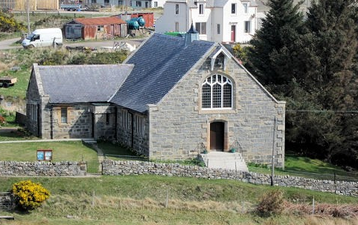
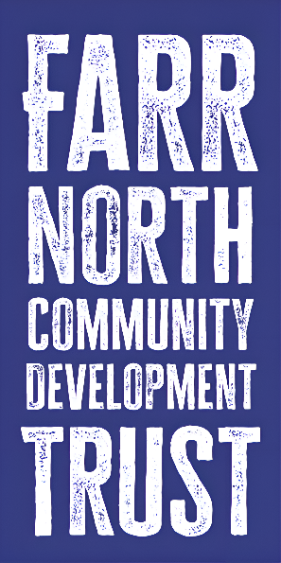
BETTYHILL CHURCH PROJECT

  - RESOURCES AND LINKS
DTAS -DEVELOPMENT TRUSTS ASSOCIATION SCOTLAND Home - DTAS Community Ownership Support Service
The New Futures programme- Former Places of Worship, is a funded 3 year programme (Jan 2025-Dec 2027) offering enhanced support to Community Groups thinking about taking former places of worship into community ownership. They offer a range of resources and links as well as examples of what other Community Groups have achieved and training events.
New Futures Programme – Former Places of Worship - DTAS Community Ownership Support Service
Recordings of online training:
Resources - DTAS Community Ownership Support Service
New Futures Workshop - Finance and Fundraising: Mainstream Funders
New Futures Workshop - Finance and Fundraising 2: Other Funding Methods
New Futures Workshop - Your Building: A Guide
New Futures Workshop - Business Planning

